

Zoho Implementation Proposal For


24 May 2025
Created By:
Priyam Modi
+91 8591044966
priyam@fristinetech.com

About Fristine Infotech
Fristine Infotech is India's leading Premium Zoho Partner helping clients across markets, industries & geographies solve complex business problems through bespoke consultation, implementation, and adoption of various Zoho Applications.

We have been a strategic partner for Zoho for the last 8 years and have successfully completed over 200+ implementations across Marketing, Sales, Operations, Finance, and Support Functions.

For More Information Please Visit our website: Fristine Infotech

Our Recent Awards:


Our Clients:
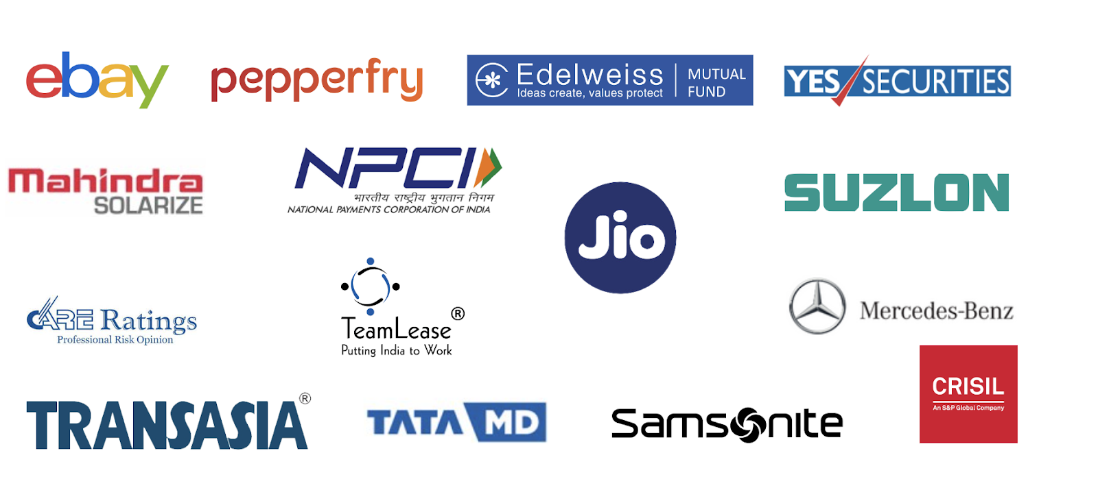

Proposal:
Solid Plus 3D Tech INC currently using Zoho applications to manage their business, is now looking for Zoho CRM, Reseller portal, Customer portal & Zoho Analytics Implementation that need to be done to streamline their entire business processes like sales, customer service management processes

Scope of work
Zoho CRM
Requirement | Status | User Persona | Fristine Remark
Organization Set up | Configuration | Admin | - Company Creation,  - Hierarchy Configuration  - Currency Configuration,  - Timezone Configuration  - Holiday List, Calendar  - Setting-up,  - Email Authentication
User & Access Control Management | Configuration | Admin | - Roles Creation,  - Profiles Creation,  - Profiles Permission,  - User Creation,  - Territory Creation
Lead Management | Configuration | Sales Team | - Configure lead module, define fields to capture data from multiple data sources  - Lead scores, Qualification parameters  - Lead assignment rules  - Webform embed on website for lead capturing  - Track stage-wise conversion time  - Webform embed on website for lead capturing
Account Management | Configuration | Sales Team | - Customer account profile creation  - Account module custom layout and field set up  - Mapping data into Accounts  - Consolidated view of all details, past deals  - Parent- Child account mapping  - Layout and validation rules  - Upto 2 layouts (Customer Layout, Reseller layout)
Contact Management | Configuration | Sales Team | - Manage multiple contacts in single accounts
Opportunity Management | Configuration | Configuration | - Opportunity management  - Stage wise progress tracking  - Payment reminders and Delivery schedules  - Licence Renewal opportunities and reminders  - Map opportunity against Reseller accounts  - Gross Profit calculation  - Manage tags and views for prioritization  - 2 Pipelines (Sales , Set up or Service)
Products / Services | Configuration | Configuration | - Product and Service list with prices
Activity Management | Configuration | Sales Team | - Create tasks, calls & meetings Assign tasks and activities to different users.  - Task creation and completion  - Meeting records, outcomes and notes  - Meeting frequency  - Generate activity reports.
Cases Management | Configuration | Sales Team | - To track customer complaints, requests and queries
Custom Functions | Configuration | Sales Team | - Develop custom functions  - (assuming upto 3-4 custom functions)
Email Parser |  |  | - Email parser, template, parser rule, custom actions
Quotation Management | Configuration | Sales Team | - Raise Quotes  - Quote history  - Sync SO and Invoices from Order management system (manual)  - Document print templates (1 each if required)  - Attachment copy  - Mapping Quotes, SO and Invoices against Customer accounts and Opportunities
Sales Order | Configuration | Sales Team | - Document print templates (1 each if required)  - Mapping Quotes & SO against Customer accounts and Opportunities
Invoice Module | Configuration | Sales Team | - Document print templates (1 each if required)  - Mapping Invoice against Customer accounts and Opportunities
Email Templates | Configuration/Customization | Sales Team | - Email templates  - Reminder to operations and other teams for set up  - Customer notifications  - (Approx. 3-4 email templates)
360 degree view | Configuration/Customization | Sales Team | - Custom Canvas views (upto 2)  - Customer 360  - Reseller 360
Custom Portals | Customization | Sales Team | - Develop custom portal (upto 2)  - Customer portal & Reseller portal  - Manage portal users and access  - Manage CRUD rights for portal users  - (Additional portal cost if separate portals required, idea is to have 2 user types in portal (End Customer / Reseller) as invoicing is done to resellers and not the end customer.)
Additional Custom Modules (up to 4) | Customization | Sales Team | - Up to 4 Custom modules as per the Solid Plus 3D team's requirement
Workflow Automation Setup | Configuration | Admin Team | - 8-10 Standard Workflow  - 5-6 Advance Workflow  - Multi level Approval Process  - Blueprints up to 2-4 (if required)  - Contract renewal reminders  - Workflow rules, blueprints, macros, approval processes, Custom workflows , action buttons, send notifications etc., Blueprints
Reports & Dashboards | Configuration | Sales / Admin Team | - Up to 10 standard CRM Reports and 2 Dashboards,  - Custom Reports and Dashboard (up to 5)  - Custom reports creation  - Real time updated data  - Up to 10 custom reports and 5 dashboards  - Up to 2-3 widget reports
Email Configuration | Configuration | Admin | - Setting up email extensions and communication tools within Zoho CRM  - Up to 2-3 Email templates, POP/IMAP configuration, email authentication (SPF/DKIM)  - Last activity time calculations and Interaction reminders

Zoho Analytics
Requirement | Status | User Persona | Fristine Remark
Customised Reports & Holistic Dashboards | Customization | Admin | - Build consolidated dashboards with data from multiple modules  - Provide a 360° view of customers and resellers in business.  - Up to 12-15 Advance Reports & 2-3 Dashboards
Data Migration, UAT & Go-Live Support
Requirement | Status | User Persona | Fristine Remark
Data Migration | Time & Material | Admin / IT Team | - One Time Data Migration from existing applications  - Assistance with ETL activities  - Guiding with data cleaning required  - Manual data uploads
UAT | Time & Material | Admin / IT Team | - Identify UAT test cases  - Set up UAT environment  - Test case execution planning  - Support UAT execution and creating defect logs  - Resolve issues and retest  - Final UAT sign-off
Go Live Support | Support | IT Team | - User Training  - Custom user guide.  - 30 Days Hyper- care
Project Team
Sr .no | Role | Role Description
1. | CTO | ‌ Accountable for Architecture Plan and Risk Mitigation.
2. | Project Manager | Accountable for overall project outcomes.  Day-to-day control and management of progress & Status.
3. | Sr Business Analyst | ‌ Accountable for overall Business/functional requirements and User Training.  Responsible for creating Business Process/Product Backlog.
4. | Junior Business Analyst | ‌ Accountable for Helping in the documentation of Business/Functional requirements.
5. | Sr Developer | Accountable for Quality Development.  Responsible for Completion of development/Implementation  task.
6. | QA/Software Test | Accountable for QA/Testing of the application.  Responsible for Test planning and execution.

Project Governance & Checkpoints
Sr .no | Type of Governance and Checkpoint
1. | ‌Requirement Gathering from all business stakeholders
2. | ‌Functional Solution Document (FSD) Review
3. | ‌FSD Sign-off
4. | ‌Doubt clarification during the development phase
5. | ‌User walkthrough session
6. | ‌User Acceptance Testing Round
7. | ‌Ticket submission on identified issues
8. | ‌User training Zoho CRM, Reseller Portal & Customer Portal Solution
9. | ‌Leadership sign-off

Project Plan:
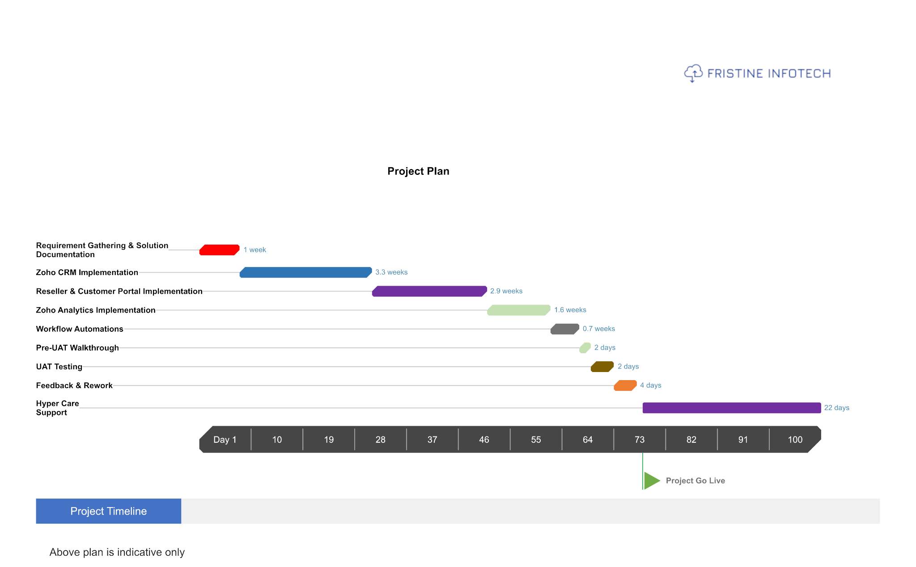

Note - This is a tentative project plan, a detailed Plan will be shared after requirement gathering.

Escalation Process
However, from time to time, there might be project issues/dependencies
That can impact progress and result in an overall impact on timelines with
a Cascaded impact on effort and project costs, if not addressed on time.
While the project team will attempt to resolve such issues amicably and in a timely
manner, the escalation path below provides a mechanism for the stakeholders both Invest India and Fristine to intervene, resolve issues, and attempt
To bring the project back on track.

Sr .No | Escalation Matrix |  |  | Response Time  (Working Days)
1. | Level 1- Sr Business Analyst |  |  | 4 Hours
2. | Level 2 - CTO |  |  | 1 Day
3. | Level 3 - CEO |  |  | 3 Days
Note: Fristine Infotech Business-day timings are defined as 10:00 AM to 6:00 PM,
Monday to Friday, excluding public holidays
Constraints & Limitations
- The actual delivery date may change based on the timely response of various stakeholders.
- All third-party Integrations will depend on the technical capabilities & API support of those platforms.
- Implementation will depend on the Zoho platform's current capability & limitations.
- All Zoho Plans have limits in Records, Storage (both data & file), Custom functions, and API calls. If limits are exceeded during data migration or usage, the Solid Plus 3D team will need to purchase additional add-ons to the Zoho plan as & if required.
- The above scope is basis initial understanding and inputs from the client. Final scope may evolve over time as we discover requirements details.
- No integrations considered in above scope apart from native CRM webform embedment and email functionality. If any other required, the efforts have to be considered separately.
- Accurate masters, information and formats expected from clients for fields, templates and layout changes. for initial Data migration uploads, data is expected in Zoho specific formats from the client team. FI team will not be responsible for data cleanliness, will only assist with required data templates and uploads
- We have estimated certain efforts for Data migration as per the requirement discussions. Efforts above certain estimates to be considered on Time and material basis in managed services
- We have considered a certain number of components for Reports and Dashboards, forms and similar factors. Any development above the mentioned limits will be considered in managed services. Additional clarity on type of reports, dashboards and views, related lists might affect the scope and estimates.
- Client IT team to embed webforms, Zoho CRM APIs will be exposed.
- Any financial reconciliation and calculations in the system or from other systems are the responsibility of the client team. It will be the responsibility of users that data is fed incorrectly.
- The process flow and calculation logics has to be provided by the client team. The Process flow will be designed based on our preliminary understandings during pre-sales process, the solution architecture may change after we have a detailed requirement gathering for BRD & FSD.
- No ADL data lake or any other DMS integration considered in the scope. Additional Data storage, File storage, data imports and exports, data back ups, data enrichments, API credits, Functions credits,Automated action calls, Webhook calls, Mail merge credits, Webform analytics, notification email credits will be purchased separately directly from Zoho as per business requirement. Set up cost will be considered separately.
- Purchase of any 3rd party services to be considered separately, out of current scope. Maintenance efforts required for future maintenance of connections will be considered separately under managed / Support services.
Commercials:
Software Implementation:
Sr. No. | Particulars | Commercial  Type | Estimated Hours | Hourly Rate | Total Amount (INR)
1. | Zoho CRM, Reseller & Customer Portal Implementation Cost | Project-based | -
2. | Zoho Analytics Implementation Cost | Project-based | -
3. | 30 days of Hyper-care on the delivered item (no new change request) | Included in Project | - | -
Total Without Optional Managed Service [Exclusive of GST]
Discount 10%
After Discount Total Without Optional Managed Service [Exclusive of GST]
4. | (Optional)  Managed Services 120 Hours for 12 Months
Total With Optional Managed Service[Exclusive of GST]

Note:

Above pricing exclusive of GST
- Third-party software License cost not included in this proposal Solid Plus 3D team need to purchase separately.
- Retainer plan post-hyper care for enhancement/maintenance.
- Client agrees to provide timely sign offs with a grace period of 7 days not with standing and client-side delays. The invoice needs to be paid as per the PO terms agreed and not partially.
- Training includes User training only, we do not provide admin training.
- In case of on-site visits travel, food, and lodging are required, it will be charged separately after written approval from the client.
- The cap of the workflow Automation, Templates etc will be done subject to use-case, the maximum cap for the same is 10. If the business use case is achieved in Less than 10 limits, the work shall be marked as completed and relevant payment will be released
Payment Terms
- Zoho License cost needs to be paid in full upfront to Zoho in advance
- 40% Implementation Cost Payable in advance
- 60% Implementation Cost Payable on UAT Sign-Off
- For Time & Material consumption, actual hours consumption will be tracked via Zoho Projects.
- Retainer services will be billed quarterly in advance.

Timeline:
- Resource Mobilization Period: 2 Weeks after Duly signed PO is received from the Client.
- The entire project will take 10 Weeks plus 2 Weeks buffer.

Next Steps:
Steps | Agenda | (FI Team) | (Solid Plus 3D Team)
Service Level Agreement | This will define all the  Terms and conditions from both parties | Sales Representative | Champ
Software License (If Required) | Over here procurement  Of license would be done | Sales Representative or Zoho Team | Champ
Vendor Registration  (If Required) | If any vendor registration required to be done for onboarding | Sales Representative | Champ
Purchase order | Solid Plus 3rd team needs to raise  PO for Service Fee and License Fee to Zoho separately | Not Applicable | Finance Team
Invoicing | Solid Plus 3D Tech team needs to process invoicing to Zoho and Fristine separately | Accounting Manager | Finance Team

